**Memo**

**Senior Design**

ENG EC 463

To: Professor Pisano, Professor Alshaykh

From: Michael Ethier, Solomon Utain, Ami Vyas, Alexander Wang

Team: Team 3

Date: 4/4/2017

Subject: Functional Deliverable Test Report

**1.0 Project Objective**

1.1 - The overall goal of this project is to develop a miniature DOS probe capable of measuring metabolic changes in fatty tissue over time. This data would give insight into the hemodynamics of a patient when used as a finger probe and it would also show the effectiveness of various chemotherapy treatments in individual cases of breast cancer when used as a breast probe.

1.2 - For practical clinical use of this probe, another goal of this project is to implement a software system that uses a tagging database to store technical data for each data file. This would allow clinicians to quickly search through a large amount of patient records by using search queries, which would make it easier for clinicians to access data that could give insight into measurement trends.

**2.2.0 Test Objective and Significance**

2.2.1 - The significance of this testing is to evaluate our board against the requirements given to us by our customer at the beginning of the project. It is also to ensure that everything in our system is functioning together - including our APD PCB, VCSEL PCB, high voltage converter, and tagging database, along with the external lab components. The signal and noise testing will ensure that the current switch, voltage, and current settings of the board provide the optimal signal-to-noise ratio for our board without saturating the signal. The drift test will ensure that our measurements stay within 5% of their original value (as per the requirement) over an hour. The phantom sweep will investigate whether our product is accurate within 10% of the benchtop system.

**2.3.0 Equipment and Setup**

2.3.1 - Hardware Setup

Place the VCSEL into the VCSEL PCB and make sure that the ground pin on the VCSEL lines up with the top pin on the VCSEL PCB. Connect the current controller to the biased T and then connect the biased T to both the VCSEL PCB and the RF switch. Make all of these connections using RF connectors. Do this for all 4 wavelengths. Supply 5 V DC to the RF switch. Make sure the evaluation board switches are in the Low Gain, DCFB on configuration. These switch settings correspond with the table below. Make sure all of the USB connections are in place and the computer is running in 32-bit mode for LabView control of components. Make sure that output 1 for the evaluation board is connected to Port 2 on the network analyzer using an RF connector. Connect the output from the high voltage converter to the high voltage input on the APD PCB. Ensure that all of the voltage converters are connected, and plug the AC to DC converter into an outlet to power the system. Referring to the diagram below for the high voltage converter PCB, input pin 5 should be connected to the 12V DC output from the AC to DC converter. Input Pins 4 and 7 should be connected to the output of the 5V DC to DC converter. Input Pins 3, 6, and 8 should all be connected together, while Input Pins 1 and 2 should be grounded. Additionally, the inputs for both the 3.3V DC to DC converter and the 5 V DC to DC converter should be connected to the 12V output of the AC to DC converter. Finally, the output of the 3.3V DC to DC converter should be connected to the low voltage input of the APD PCB.

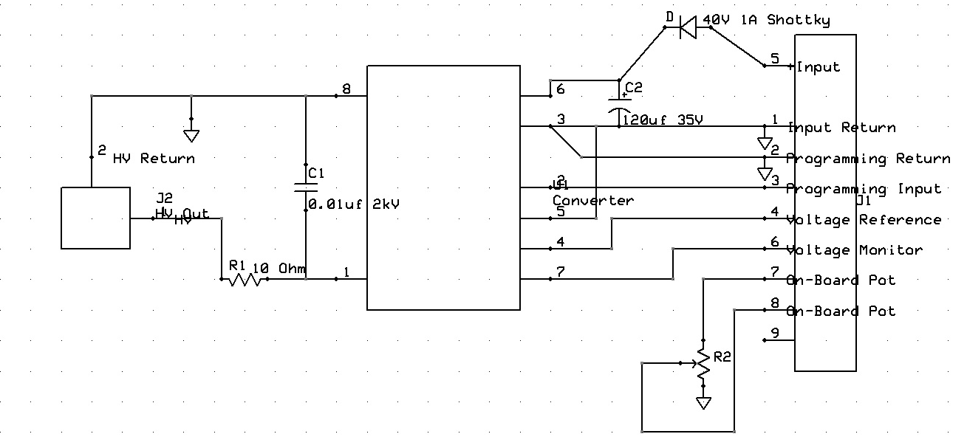

High Voltage PCB Schematic

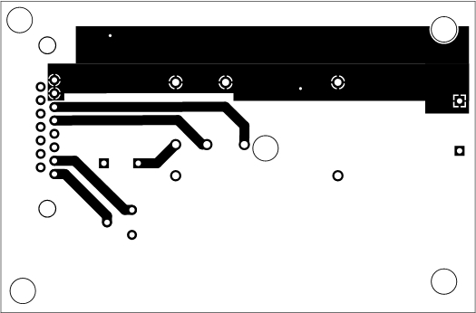

High Voltage PCB (Bottom Layer)

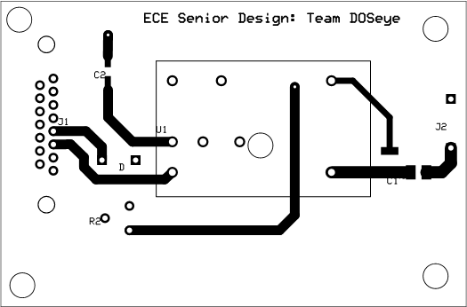

High Voltage PCB (Top Layer)

For the network analyzer, change measurement to S21 and autoscale the graph. The start and stop frequencies are set to 50 MHz and 500 MHz with a 6 dBm power limit. On the current supply, the current for the lasers should be 10,15, 5 and 10 mA for the 660, 680, 775, and 795 nm lasers respectively.

On the computer, open the DOS System -> Benchtop DOS System -> Senior Design to open the LabView system. Enable saving, and input a file name and ID. Hold the VCSEL so it outputs into the phantom. Raise the phantom platform so that the mounted APD is flush onto the surface of the phantom near the VCSEL with a source-detector separation of 10mm. Input this separation into the LabView program. Make sure that both the VCSEL and APD are near the center of the phantom because near the edges the light scatters in a different way which is not ideal for testing. Finally, hit the “Take Measurements” button to start the measurements.

*2.3.2 - SNR Testing Setup*

To meet the requirement of a 10:1 signal to noise ratio, we must take both signal and noise measurements using our current setup. The signal measurement should be taken using the setup described above, preferably on the Acrin 009 phantom, which simulates breast tissue. Next, take noise-floor measurements by placing the VCSEL flush onto a piece of rubber which allows no light scattering. These two measurements should be divided across the frequency range and an SNR plot of SNR vs. Frequency can be created. If the signal to noise ratio is above 10 (20 dB) for most or all of the frequency range, the requirement has been met.

*2.3.3 - Precision Testing Setup*

To meet the requirement of >95% precision for the probe, a drift test should be conducted. This requires the same measurement to be taken on the same phantom with the same settings (nothing changed) every minute for an hour. The settings we will use are described above, using the ACRIN 009 or INO 09 phantoms. If the measurements taken in the 60 minute period do not differ from each other by more than 5% of the initial value, the requirement has been met. This test will not be conducted during the testing period due to its length. The data for this test will be processed by a graduate student in our customer’s lab and reported in the test report.

*2.3.4 - Accuracy Testing Setup*

To meet the requirement for >10% accuracy, a phantom sweep test must be conducted. This requires the same measurement, with the settings detailed above, to be taken on an entire phantom set. This will parse about 20 or more phantoms. The scattering and absorption coefficients that can be found using the collected data will be compared to the known values and if the values are within +-10% of the standard, the requirement will be met. This test will not be conducted during the testing period due to its length. The data for this test will be processed by a graduate student in our customer’s lab and reported in the test report.

**2.4.0 Measurements and Data**

2.4.1 - SNR Testing Results

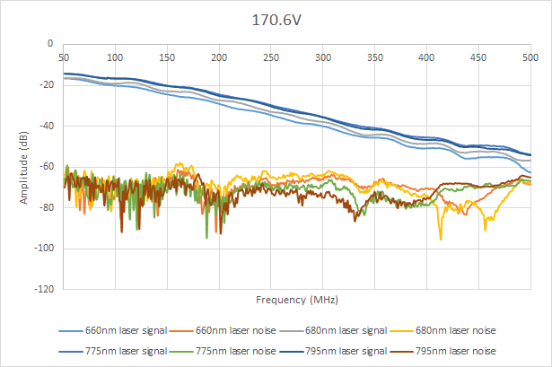

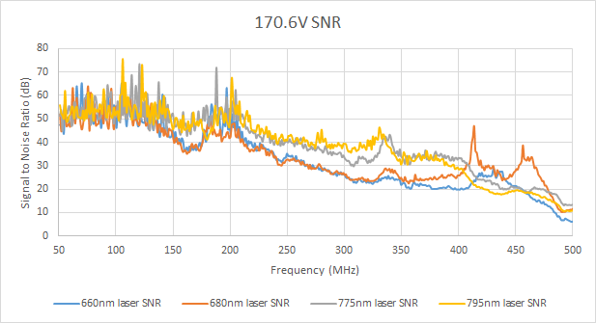

2.4.2 - Precision Testing Results

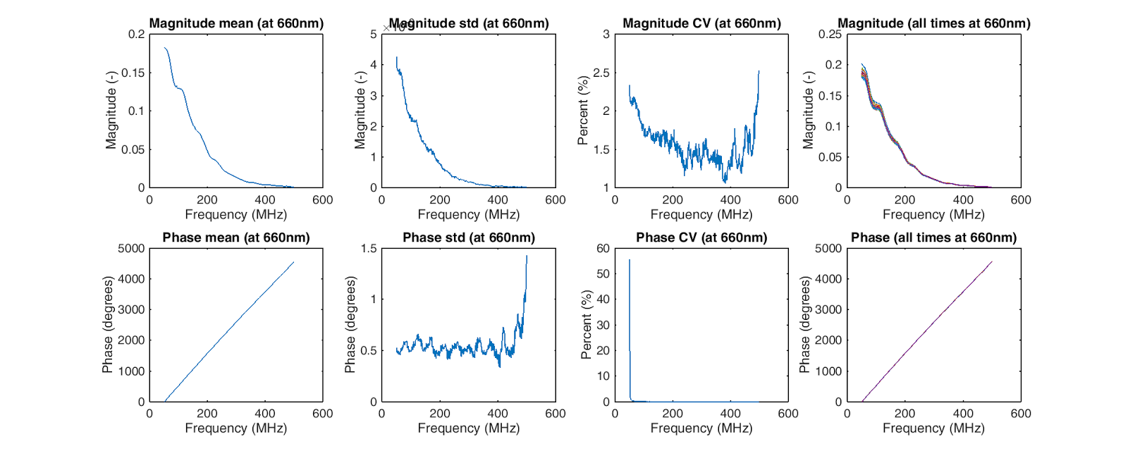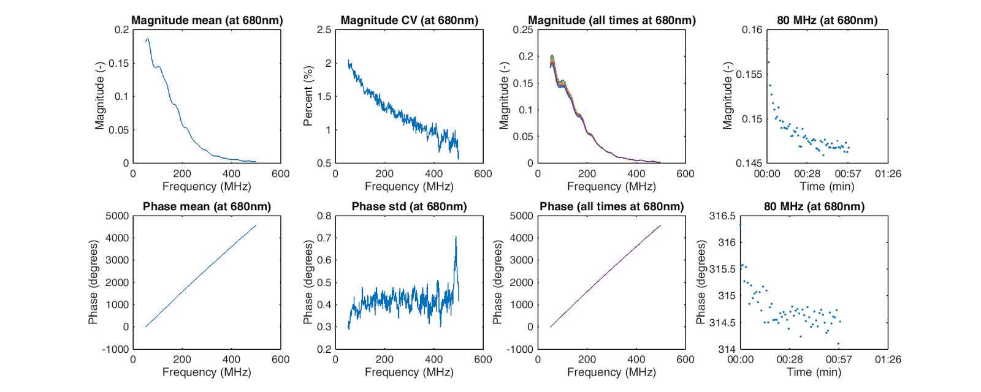

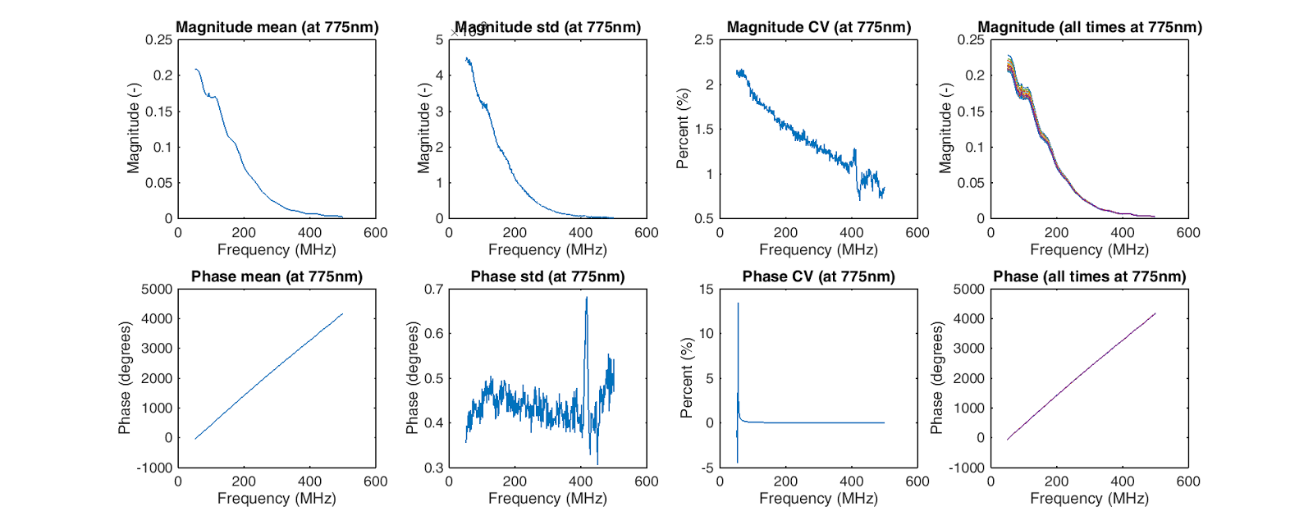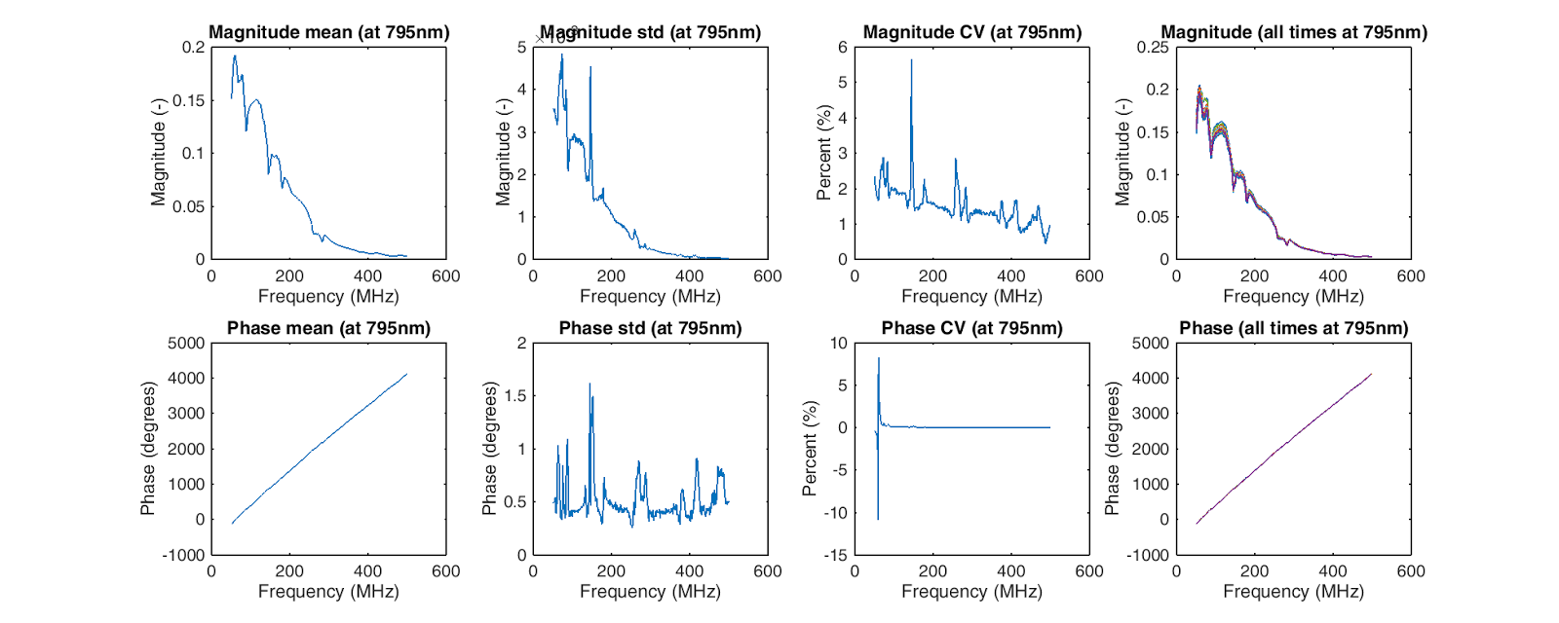

Plotted: Standard deviation as a percentage of mean. Plotted by MATLAB code provided by the customer.

2.4.3 - Accuracy Testing Results

|  |  |  |  |  |  |  |  |  |  |  |  |  |  |  |  |
| --- | --- | --- | --- | --- | --- | --- | --- | --- | --- | --- | --- | --- | --- | --- | --- |
| **Wavelength** | **ACRIN** | **AAT** | **b4h1** | **b4h2** | **b4h3** | **b5h4** | **b5h5** | **b5h6** | **b6h7** | **b6h8** | **b6h9** | **bpav1** | **bpav2** | **bpav3** | **bpav4** |
| 660 | 0.0173 | 0.0501 | 0.0242 | 0.0433 | 0.0912 | 0.0216 | 0.0470 | 0.0758 | 0.0215 | 0.0424 | 0.0773 | 0.0063 | 0.0057 | 0.0050 | 0.0039 |
| 660 | 0.0128 | 0.0141 | 0.0134 | 0.0147 | 0.0173 | 0.0119 | 0.0164 | 0.0217 | 0.0080 | 0.0119 | 0.0174 | 0.0026 | 0.0098 | 0.0022 | 0.0043 |
| Percent Error | 0.2583 | 0.7191 | 0.4444 | 0.6599 | 0.8107 | 0.4499 | 0.6509 | 0.7136 | 0.6284 | 0.7192 | 0.7745 | 0.5830 | -0.7331 | 0.5670 | -0.1042 |
| 680 | 0.0158 | 0.0482 | 0.0226 | 0.0407 | 0.0858 | 0.0200 | 0.0432 | 0.0728 | 0.0201 | 0.0401 | 0.0735 | 0.0060 | 0.0054 | 0.0048 | 0.0037 |
| 680 | 0.0124 | 0.0082 | 0.0145 | 0.0121 | 0.0110 | 0.0121 | 0.0132 | 0.0111 | 0.0063 | 0.0064 | 0.0103 | 0.0026 | 0.0108 | 0.0022 | 0.0053 |
| Percent Error | 0.2116 | 0.8308 | 0.3581 | 0.7033 | 0.8714 | 0.3963 | 0.6951 | 0.8474 | 0.6872 | 0.8396 | 0.8599 | 0.5695 | -1.0173 | 0.5364 | -0.4156 |
| 775 | 0.0094 | 0.0340 | 0.0153 | 0.0270 | 0.0553 | 0.0131 | 0.0266 | 0.0509 | 0.0134 | 0.0262 | 0.0493 | 0.0045 | 0.0042 | 0.0037 | 0.0028 |
| 775 | 0.0110 | 0.0087 | 0.0121 | 0.0138 | 0.0152 | 0.0095 | 0.0153 | 0.0134 | 0.0051 | 0.0062 | 0.0129 | 0.0024 | 0.0083 | 0.0020 | 0.0049 |
| Percent Error | -0.1627 | 0.7434 | 0.2068 | 0.4873 | 0.7251 | 0.2751 | 0.4258 | 0.7363 | 0.6175 | 0.7635 | 0.7385 | 0.4754 | -0.9525 | 0.4459 | -0.7181 |
| 795 | 0.0086 | 0.0308 | 0.0140 | 0.0244 | 0.0492 | 0.0118 | 0.0237 | 0.0458 | 0.0121 | 0.0233 | 0.0442 | 0.0043 | 0.0041 | 0.0035 | 0.0027 |
| 795 | 0.0085 | 0.0485 | 0.0090 | 0.0114 | 0.0134 | 0.0069 | 0.0124 | 0.0119 | 0.0038 | 0.0049 | 0.0111 | 0.0200 | 0.0114 | 0.0014 | 0.0037 |
| Percent Error | 0.0060 | -0.5758 | 0.3552 | 0.5328 | 0.7288 | 0.4143 | 0.4755 | 0.7398 | 0.6880 | 0.7890 | 0.7481 | -3.6726 | -1.7955 | 0.6071 | -0.3615 |

µa for the phantom set in the lab. Lab standard as the top measurement, our measurements as the bottom for each wavelength. Percentage values are not multiplied by 100.

|  |  |  |  |  |  |  |  |  |  |  |  |  |  |  |  |
| --- | --- | --- | --- | --- | --- | --- | --- | --- | --- | --- | --- | --- | --- | --- | --- |
| **Wavelength** | **ACRIN** | **AAT** | **b4h1** | **b4h2** | **b4h3** | **b5h4** | **b5h5** | **b5h6** | **b6h7** | **b6h8** | **b6h9** | **bpav1** | **bpav2** | **bpav3** | **bpav4** |
| 660 | 0.7960 | 0.8999 | 0.6852 | 0.6654 | 0.4691 | 0.7405 | 0.5215 | 0.7551 | 1.0215 | 1.0918 | 0.6637 | 1.3999 | 0.5484 | 1.3011 | 1.0481 |
| 660 | 0.7248 | 1.8968 | 0.6309 | 0.9692 | 1.4557 | 0.6956 | 0.9414 | 2.1147 | 1.1343 | 2.0051 | 1.7767 | 1.2315 | 0.2640 | 1.2889 | 0.8543 |
| Percent Error | 0.0894 | -1.1079 | 0.0791 | -0.4566 | -2.1035 | 0.0607 | -0.8052 | -1.8007 | -0.1104 | -0.8366 | -1.6771 | 0.1203 | 0.5186 | 0.0094 | 0.1849 |
| 680 | 0.7753 | 0.8891 | 0.6726 | 0.6549 | 0.4763 | 0.7290 | 0.5195 | 0.7682 | 1.0021 | 1.0900 | 0.6706 | 1.3504 | 0.5351 | 1.2524 | 1.0083 |
| 680 | 0.6917 | 2.2111 | 0.5526 | 0.9753 | 1.6273 | 0.6393 | 0.9547 | 2.9103 | 1.1782 | 2.3526 | 2.0894 | 1.2260 | 0.2516 | 1.2701 | 0.8259 |
| Percent Error | 0.1078 | -1.4867 | 0.1785 | -0.4893 | -2.4167 | 0.1230 | -0.8377 | -2.7885 | -0.1757 | -1.1583 | -2.1155 | 0.0921 | 0.5298 | -0.0142 | 0.1809 |
| 775 | 0.6907 | 0.8438 | 0.6205 | 0.6108 | 0.5094 | 0.6809 | 0.5107 | 0.8285 | 0.9212 | 1.0825 | 0.7022 | 1.1532 | 0.4806 | 1.0595 | 0.8513 |
| 775 | 0.5180 | 1.4668 | 0.4284 | 0.6446 | 0.9688 | 0.5463 | 0.6217 | 1.7579 | 0.9539 | 1.5719 | 1.3041 | 1.0148 | 0.2647 | 1.0454 | 0.7041 |
| Percent Error | 0.2500 | -0.7384 | 0.3096 | -0.0554 | -0.9017 | 0.1977 | -0.2173 | -1.1217 | -0.0354 | -0.4521 | -0.8573 | 0.1201 | 0.4493 | 0.0133 | 0.1730 |
| 795 | 0.6753 | 0.8352 | 0.6108 | 0.6025 | 0.5162 | 0.6720 | 0.5090 | 0.8408 | 0.9063 | 1.0811 | 0.7085 | 1.1183 | 0.4707 | 1.0256 | 0.8237 |
| 795 | 0.5179 | 0.1655 | 0.4385 | 0.6040 | 0.8715 | 0.5538 | 0.6045 | 1.5270 | 0.8970 | 1.3904 | 1.1681 | 0.2252 | 0.2499 | 0.9696 | 0.6841 |
| Percent Error | 0.2331 | 0.8018 | 0.2822 | -0.0024 | -0.6882 | 0.1759 | -0.1876 | -0.8161 | 0.0102 | -0.2861 | -0.6488 | 0.7987 | 0.4691 | 0.0545 | 0.1695 |

µs for the phantom set in the lab. Lab standard as the top measurement, our measurements as the bottom for each wavelength. Percentage values are not multiplied by 100.

**2.5.0 Conclusions**

2.5.1 - SNR

The SNR testing results show that the probe meets our client’s requirements of having an SNR of at least 10 over the range of 50 MHz to 500 MHz. The 660 nm wavelength dips below an SNR of 10 at about 490 MHz but this is near the end of the range and at higher frequencies the APD is slightly less accurate so the signal is lower.

2.5.2 - Precision

The precision results show that our measurements are within the requirement from our customer which was that the measurements taken over time must be consistent with each other. The precision must be within plus or minus five percent of the original values taken over one hour. Three of the wavelengths remained within 2 percent of the original value while the 795 nm was for the most part within 2 percent of the original value but had peaks that spiked up to a 5 percent deviation. This means that our probe has satisfied the precision requirement and is very consistent when taking measurements over a longer period of time such as one hour.

2.5.3 - Accuracy

Comparing our data with the benchtop data, our accuracy seems to be off by a decent amount. Here we do not meet our customer’s goal to have less than 10% error with the absorption and scattering coefficients with each phantom, as our smallest error compared to the benchtop system less than 1%, while for most of the measurements the error was around 50% or higher. This could be due to many different factors. One factor could be that since the SMA connectors are more than one inch away from the APD, the distance and length of the traces could possibly add noise since they are carrying signals in the RF range. Another possible reason could be that based off our previous testing and measurements, we had determined that the Low gain, DCFB On settings are optimal for our device. However, we previously had not measured and had our data analyzed for accuracy, and had based this choice mainly on the signal levels and the signal-to-noise ratio. We may need to test the High gain and DCFB off settings to see if we achieve a higher accuracy. Lastly, it might be possible that the APD is simply not capable of the same level of accuracy as the benchtop system and cannot have less than 10% error.

**3.2.0 Test Objective and Significance**

3.2.1 The objective of these tests is to verify the required functionality of the software system. The software system must be able to autonomously associate tags to files in its database, and then be able to use this data to perform search queries and present files that meet query parameters. The significance of this functionality is to provide a means to organize the multitude of data files contained in the clinical/research data archive. This organization would allow clinicians to quickly search through a large amount of patient records by using search queries, which would make it easier for clinicians to access data that could give insight into measurement trends.

**3.3.0 Equipment and Setup**

3.3.1 *Assumptions*

As with the final installed system, this setup assumes data files have been transferred to either the machine hosting the database, or to the shared research drive where the entirety of the clinical data archive is stored. This testing specifically works with the former. Data files are organized in a nested directory tree, contained in multiple folders in multiple subdirectories. Data files are alongside processed data and raw data without metadata. This is to emulate the real environment that this software system will be working within.

3.3.2 *Environment*

The test machine is running a x86_64 version of Debian 8 with necessary packages installed to host the database (i.e. SQLite) as well as to host a semantic file system (i.e. TMSU) and to run Python scripts (i.e. Python 2.7).

3.3.3 *Software System*

The software system consists of discrete components communicating together. For all use cases, whether a user is appending the database or running a search query, Python scripts and TMSU have bidirectional communication over the Bash CLI, and TMSU has read+write access to the database and native filesystem.

**3.4.0 Measurements and Data**

3.4.1 *Automated Tag Association*

This test was performed within a directory containing thousands of data files acquired by our senior design group, as well as patient-anonymous clinical data. Running a tag association script looked for data files in the directory containing the script as well as all subdirectories. The script extracts tags and values from data files by parsing through each file, provided the files follow up to three known formats of metadata organization. Once tags were associated, results were verified by displaying a list of files catalogued in the database, a list of tags, a list of values, and displaying the tags and values associated with a small sample of files. The script was then run an additional time to show that only untagged files are parsed through. In this instance no new files were added, so the script completed without redundantly retagging all previously tagged files.

3.4.2 *Search Queries*

This test was performed after the automated tag association test. Search queries were performed using bash commands over the command line interface. Tags, values, multiple tags and values, and exclusions of tags and values (I.e. and, and not), and quantifiers of values (I.e. >, <, =) can be set as search filters. Query results were displayed within the file system, accessible as links to the real files. To verify results, query results were accessed and shown to match the query itself.

**3.5.0 Conclusions**

3.5.1 All base deliverables for this software system are implemented. Further, the software system works reliably and is highly versatile. Its ability to avoid redundant retagging in the automated tag association use case is ideal for working within the clinical data archive; hundreds of thousands of data files are present in the archive, and this script only needs to append the tag database with “new” files, which will happen when new clinical data continues to be recorded. With this functionality present, this system is feasibly ready to be applied to the clinical data archive. All that is left to be done is expand on the implemented functionality by creating a friendly user interface and implementing additional client-requested functions.